DIS-Asia-Gandhara-Buddha Head

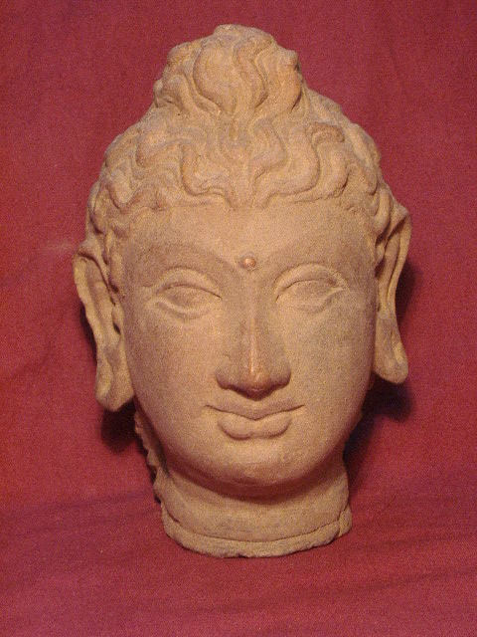

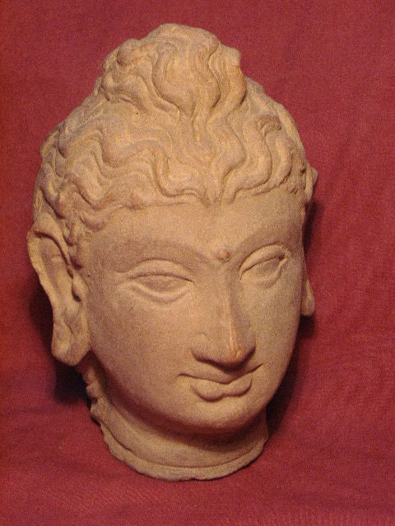

# Order details

## Sales order

Sold by [sak2014*14](http://myworld.ebay.com/sak2014*14) ( [345](http://feedback.ebay.com/ws/eBayISAPI.dll?ViewFeedback&userid=sak2014*14) )

### Delivery package 1 of 1

Estimated delivery Thursday, Feb 11, 2016 - Monday, Feb 29, 2016

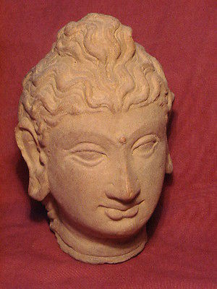

#### [Ancient Large Teracotta Buddha Head Gandhara/Gandharan C.300 AD #895](http://www.ebay.com/itm/121805866879)

|  |  |
| --- | --- |
| Item price | $275.00 |
| Quantity | 1 |
| Item number | 121805866879 |
| Shipping service | Economy Shipping from outside US |